|  |  |
| --- | --- |
| Activity | Data Type |
| Number of beatings from Wife | Discrete |
| Results of rolling a dice | Discrete |
| Weight of a person | Continuous |
| Weight of Gold | Continuous |
| Distance between two places | Continuous |
| Length of a leaf | Continuous |
| Dog's weight | Continuous |
| Blue Color | Discrete |
| Number of kids | Discrete |
| Number of tickets in Indian railways | Discrete |
| Number of times married | Discrete |
| Gender (Male or Female) | Discrete |

Q1) Identify the Data type for the Following:

Q2) Identify the Data types, which were among the following

Nominal, Ordinal, Interval, Ratio.

|  |  |
| --- | --- |
| Data | Data Type |
| Gender | Nominal |
| High School Class Ranking | Ordinal |
| Celsius Temperature | Interval |
| Weight | Ratio |
| Hair Color | Nominal |
| Socioeconomic Status | Ordinal |
| Fahrenheit Temperature | Interval |
| Height | Ratio |
| Type of living accommodation | Ordinal |
| Level of Agreement | Ordinal |
| IQ (Intelligence Scale) | Ratio |
| Sales Figures | Ratio |
| Blood Group | Nominal |
| Time Of Day | Ordinal |
| Time on a Clock with Hands | Interval |
| Number of Children | Nominal |
| Religious Preference | Nominal |
| Barometer Pressure | Interval |
| SAT Scores | Interval |
| Years of Education | Ordinal |

Q3) Three Coins are tossed, find the probability that two heads and one tail are obtained?

Ans:

P (Two heads and one tail) = N (Event (Two heads and one tail)) / N (Event (Three

coins tossed))

= 3/8 = 0.375 = 37.5%

Q4) Two Dice are rolled, find the probability where sum is

1. Equal to 1
2. Less than or equal to 4
3. Divisible by 2 and 3

Ans:

Number of possible outcomes for the above event is

N (Event (Two dice rolled)) = 6^2 = 36

1. P (sum is Equal to 1) = ‘0’ zero null nada none.
2. P (Sum is less than or equal to 4) = N (Event (Sum is less than or equal to

4)) / N (Event (Two dice rolled))

= 6 / 36 = 1/6 = 0.166 = 16.66%

1. P (Sum is divisible by 2 and 3) = N (Event (Sum is divisible by 2 and 3)) / N

(Event (Two dice rolled))

= 6 / 36 = 1/6 = 0.16 = 16.66%

Q5) A bag contains 2 red, 3 green and 2 blue balls. Two balls are drawn at random. What is the probability that none of the balls drawn is blue?

Ans: Total number of balls =7 balls

N (Event (2 balls are drawn randomly from bag) = 7! / 2! * 5!

= (7*6*5*4*3*2*1) /

(2*1) * (5*4*3*2*1)

N (Event (2 balls are drawn randomly from bag) = (7*6)/ (2*1) = 21

If none of them drawn 2 balls are blue = 7 – 2 = 5

N (Event (None of the balls drawn is blue) = 5! / 2! * 3! = (5*4) / (2*1)

= 10

P (None of the balls drawn is blue) = N (Event (None of the balls drawn is blue) /

N (Event (2 balls are drawn randomly from

bag)

= 10 / 21

Q6) Calculate the Expected number of candies for a randomly selected child

Below are the probabilities of count of candies for children (ignoring the nature of the child-Generalized view)

|  |  |  |
| --- | --- | --- |
| CHILD | Candies count | Probability |
| A | 1 | 0.015 |
| B | 4 | 0.20 |
| C | 3 | 0.65 |
| D | 5 | 0.005 |
| E | 6 | 0.01 |
| F | 2 | 0.120 |

Child A – probability of having 1 candy = 0.015.

Child B – probability of having 4 candies = 0.20

Ans:

0.015+0.8+1.95+0.025+0.06+0.24 = 3.09

Q7) Calculate Mean, Median, Mode, Variance, Standard Deviation, Range & comment about the values / draw inferences, for the given dataset

* For Points, Score, Weigh>

Find Mean, Median, Mode, Variance, Standard Deviation, and Range and also Comment about the values/ Draw some inferences.

**Use Q7.csv file**

**Ans:**

Mean for Points = 3.59, Score = 3.21 and Weigh = 17.84

Median for Points = 3.69, Score = 3.32 and Weigh = 17.71

Mode for Points = 3.07, Score = 3.44 and Weigh = 17.02

Variance for Points = 0.28, Score = 0.95, Weigh = 3.19

Standard Deviation for Points = 0.53, Score = 0.97, Weigh = 1.78

Range [Min-Max] for Points [3.59 – 4.93], Score [3.21 – 5.42] and Weigh [17.84 – 22.9]

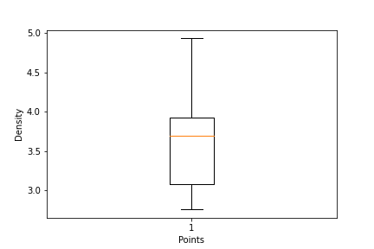Draw Inferences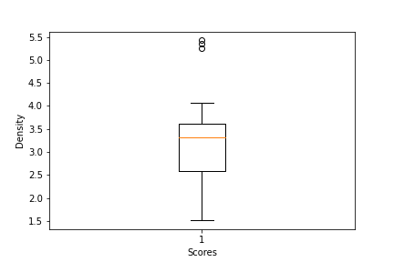

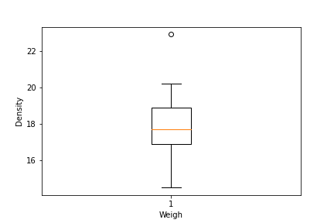

Q8) Calculate Expected Value for the problem below

1. The weights (X) of patients at a clinic (in pounds), are

108, 110, 123, 134, 135, 145, 167, 187, 199

Assume one of the patients is chosen at random. What is the Expected Value of the Weight of that patient?

Ans: Expected value = Sum (X * Probability of X)

= (1/9)(108)+ (1/9)(110)+ (1/9)(123)+ (1/9)(134)+ (1/9)(145)+ (1/9)(167)+ (1/9)(187)+ (1/9)(199)

= 145.33

**Q9) Calculate Skewness, Kurtosis & draw inferences on the following data**

**Cars speed and distance**

**Use Q9_a.csv**

# Ans skewness

speed -0.117510

dist 0.806895

skewness<0 speed it is neagtively skewed(right side of modal)

skewness>0,distance it is positively skewed(left side of modal)

**Kurtosis**

speed -0.508994

dist 0.405053

#since kurtosis less than 3 it is platykurtic

Speed

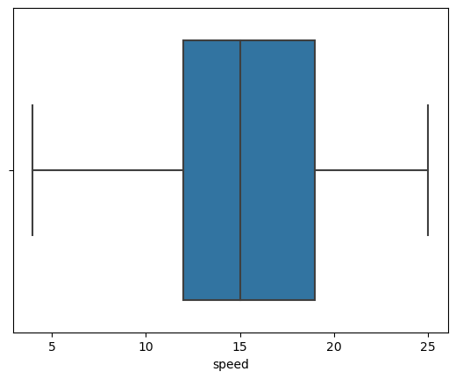

**Distance**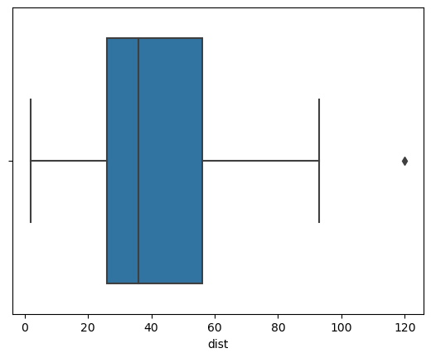

**# both speed and distance have positively skew(right skew)#dist data has outliers on maximum side**

**#both are not normally distributed**

**SP and Weight (WT)**

**Use Q9_b.csv**

Ans: Skewness

SP 1.611450

WT -0.614753

Sp-positively skewed

WT-negatively skewed

kurtosis

SP 2.977329

WT 0.950291

kurtosis for WT and SP are platycurtic

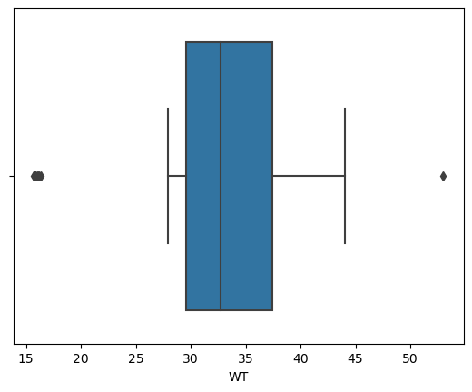

WT-right skewed

WT has outliers on maximum and minimum sides

It is not normally distributed

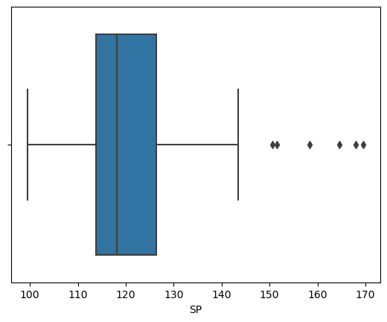

SP-right skewed

SP data has outliers

It is not normally distributed

**Q10) Draw inferences about the following boxplot & histogram**



Ans: The histograms peak has right skew and tail is on right. Mean > Median. We have outliers on the higher side.



Ans: The boxplot has outliers on the maximum side.

**Q11)** Suppose we want to estimate the average weight of an adult male in Mexico. We draw a random sample of 2,000 men from a population of 3,000,000 men and weigh them. We find that the average person in our sample weighs 200 pounds, and the standard deviation of the sample is 30 pounds. Calculate 94%,98%,96% confidence interval?

Ans: stats.norm.interval(0.94,200,30/(2000**0.5))

stats.norm.interval(0.96,200,30/(2000**0.5))

stats.norm.interval(0.98,200,30/(2000**0.5))

For 94% confidence interval Range is [ 198.73 – 201.26]

For 98% confidence interval range is [198.43 – 201.56]

For 96% confidence interval range is [198.62 – 201.37]

**Q12)** Below are the scores obtained by a student in tests

**34,36,36,38,38,39,39,40,40,41,41,41,41,42,42,45,49,56**

1. Find mean, median, variance, standard deviation.

Ans: Mean =41, Median =40.5, Variance =25.52 and Standard Deviation =5.05

1. What can we say about the student marks?

Ans: we don’t have outliers and the data is slightly skewed towards right because mean is greater than median.

Q13) What is the nature of skewness when mean and median of data are equal?

Ans: No skewness is present we have a perfect symmetrical distribution

Q14) What is the nature of skewness when mean > median?

Ans: Skewness and tail is towards Right

Q15) What is the nature of skewness when median > mean?

Ans: Skewness and tail is towards left

Q16) What does positive kurtosis value indicates for a data?

Ans: Positive kurtosis means the curve is more peaked and it is Leptokurtic

Q17) What does negative kurtosis value indicates for a data?

Ans: Negative Kurtosis means the curve will be flatter and broader

Q18) Answer the below questions using the below boxplot visualization.



What can we say about the distribution of the data?

Ans: The above Boxplot is not normally distributed the median is towards the higher value

What is nature of skewness of the data?

Ans: The data is a skewed towards left. The whisker range of minimum value is greater than maximum

What will be the IQR of the data (approximately)?

Ans: The Inter Quantile Range = Q3 Upper quartile – Q1 Lower Quartile = 18 – 10 =8

Q19) Comment on the below Boxplot visualizations?



Draw an Inference from the distribution of data for Boxplot 1 with respect Boxplot 2.

Ans: First there are no outliers. Second both the box plot shares the same median that is approximately in a range between 275 to 250 and they are normally distributed with zero to no skewness neither at the minimum or maximum whisker range.

Q 20) Calculate probability from the given dataset for the below cases

Data _set: Cars.csv

Calculate the probability of MPG of Cars for the below cases.

MPG <- Cars $ MPG

* 1. P(MPG>38)

#(p>38)

1-stats.norm.cdf(38,34.422076,9.131445)

Ans.0.34759394041453007

b.P(MPG<40)

#(p<40)

stats.norm.cdf(40,34.422076,9.131445)

Ans.0.7293498604157946

c.P (20<MPG<50)

#(20<p<50)

stats.norm.cdf(50,34.422076,9.131445)-stats.norm.cdf(20,34.422076,9.131445)

Ans.0.8988

Q 21) Check whether the data follows normal distribution

1. Check whether the MPG of Cars follows Normal Distribution

Dataset: Cars.csv

Ans:

1. MPG of cars follows normal distribution

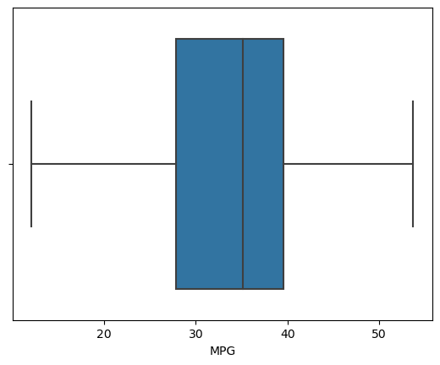

MPG feature is not normally distributed

Negatively skewed

Outliers doesnot exist

b) Check Whether the Adipose Tissue (AT) and Waist Circumference (Waist) from wc-at data set follows Normal Distribution

Dataset: wc-at.csv

Ans: Adipose Tissue (AT) and Waist does not follow Normal Distribution

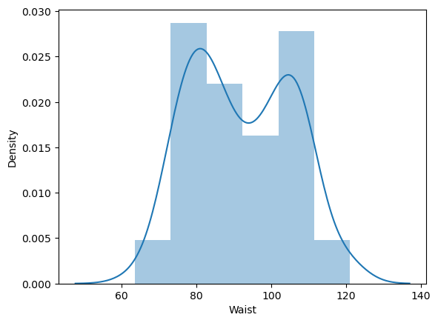

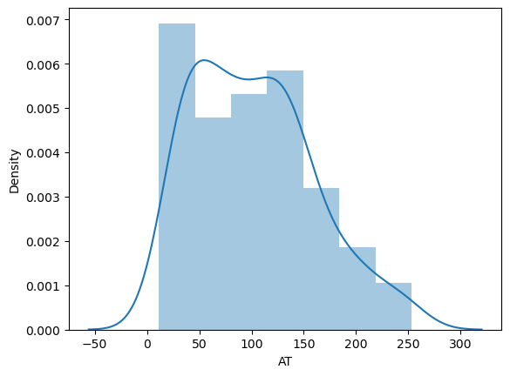

# positively skewed

# AT feature does not follow the normal distribution

# positively skewed

# Waist feature does not follow the normal distribution

Q 22) Calculate the Z scores of 90% confidence interval,94% confidence interval, 60% confidence interval

Ans:

# z value for 90% confidence interval

print('Z score for 60% Conifidence Intervla =',np.round(stats.norm.ppf(.05),4))

Z score for 60% Conifidence Intervla = -1.6449

# z value for 94% confidence interval

print('Z score for 60% Conifidence Intervla =',np.round(stats.norm.ppf(.03),4))

Z score for 60% Conifidence Intervla = -1.8808

# z value for 60% confidence interval

print('Z score for 60% Conifidence Intervla =',np.round(stats.norm.ppf(.2),4))

Z score for 60% Conifidence Intervla = -0.8416

Q 23) Calculate the t scores of 95% confidence interval, 96% confidence interval, 99% confidence interval for sample size of 25

Ans:

# t score for 95% confidence interval

print('T score for 95% Confidence Interval =',np.round(stats.t.ppf(0.025,df=24),4))

T score for 95% Confidence Interval = -2.0639

# t value for 94% confidence interval

print('T score for 94% Confidence Inteval =',np.round(stats.t.ppf(0.03,df=24),4))

T score for 94% Confidence Inteval = -1.974

# t value for 99% Confidence Interval

print('T score for 95% Confidence Interval =',np.round(stats.t.ppf(0.005,df=24),4))

T score for 95% Confidence Interval = -2.7969

Q 24**)** A Government company claims that an average light bulb lasts 270 days. A researcher randomly selects 18 bulbs for testing. The sampled bulbs last an average of 260 days, with a standard deviation of 90 days. If the CEO's claim were true, what is the probability that 18 randomly selected bulbs would have an average life of no more than 260 days

Ans.x_bar = 260

pop_mean = 270

t_value = (260-270)/(90/np.sqrt(18))

t_value= -0.4714045207910317

1-stats.t.cdf(abs(t_value),df = 17)

P=0.32167253567098353